











2
1
1







2


1
1
2
2

thanos L black
thanos LQ black

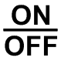













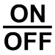




thanos L white
thanos LQ white
2
2
1
1
1
1
2
2

